**Integration: Blending Data and Visualization**

1. **Data Integration with Energy models**

Data integration is a fundamental aspect of digital twin technology. In this section, we will delve into how data is ingested into Energy models from a database, the cleaning and formatting of data for use in API, and the creation of a FastAPI application for deploying energy models as containerized services. Furthermore, we will explore the deployment of this application using Docker and Kubernetes.

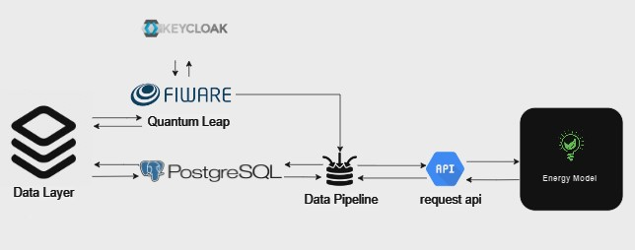

Data integration diagram

1. Data Retrieval from Database

The process of ingesting data is where it all begins. In the context of digital twins, two distinct methods are employed for data retrieval from a PostgreSQL database.

1.1 SQLalchemy: Precision in Action

SQLalchemy, a versatile Python library, acts as a reliable means to fetch data from a PostgreSQL database. It allows us to communicate with the database, asking it for the specific data we need, much like choosing the right puzzle pieces from a big box.

1.2 Keycloak and QuantumLeap APIs: Security and Harmony

Keycloak and QuantumLeap APIs provide an additional layer of security and data harmonization during the data retrieval process.

Keycloak ensures that only authorized individuals gain access to the data, maintaining the integrity of the digital twin's resources.

QuantumLeap, working in tandem with Keycloak, standardizes data retrieval from various sources, acting as a translator for data. This ensures a common language is spoken, much like bridging communication gaps between different systems.

2. Data Cleaning and Formatting

After acquiring the data, the next critical step is to prepare it for use within the digital twin.

2.1 Data Cleaning:

Data cleaning is akin to tidying up a cluttered room. It involves identifying and rectifying errors and inconsistencies, ensuring data accuracy. Just as you would fix mistakes in your room, data cleaning makes sure the data is free of inaccuracies.

2.2 Data Formatting:

Data formatting is all about putting things in the right place. It ensures that the data is presented consistently and clearly, like using the same measuring system for everyone. This makes the data more accessible and understandable within the digital twin.

3. Creating a REST based API for Energy Models

The final stage of data integration involves the development of a FastAPI application tailored to deploy energy models as containerized services. This application serves as a bridge, enabling the ingestion of formatted data into energy models.

FastAPI is a rapid web framework that simplifies the creation of application interfaces, much like a fast delivery service. With FastAPI, we make an application that allows energy models to quickly access the clean and organized data.

4. Deploying with Docker and Kubernetes

Once the FastAPI application is ready, it can be deployed using Docker and Kubernetes. Docker packages the application, while Kubernetes manages its deployment, scaling, and maintenance. Think of Docker as a container for the application, making it easy to transport, and Kubernetes as the captain ensuring it reaches its destination and runs smoothly.

In summary, data integration is the backbone of digital twin technology. It involves data retrieval, cleaning, formatting, and making it accessible for energy models. The deployment of the FastAPI application using Docker and Kubernetes ensures that everything operates seamlessly, much like a well-organized team working together.

**2. Data Integration with Visualization layer**

process of transforming raw data into actionable insights through visualization is of paramount importance. In this section, we highlight our choice of Grafana as the key visualization tool and its integration with our data source, PostgreSQL. The combination of PostgreSQL and Grafana empowers us to create dynamic custom dashboards that provide clear and insightful representations of the data stored in the database, facilitating informed decision-making and real-time monitoring.

1. The Role of Grafana in Visualization

Grafana, a leading open-source data visualization and monitoring platform, serves as the linchpin of our data integration strategy. It offers a versatile and user-friendly environment for designing, building, and sharing custom dashboards. Its capabilities extend to a wide range of data sources, making it a versatile choice for visualization.

1. Custom Dashboards for Enhanced Insights

Custom dashboards tailored to our specific needs play a crucial role in our data integration process. These dashboards are designed to visually represent the data stored in our PostgreSQL database, allowing for quick and intuitive data exploration. They enable us to display key performance indicators, monitor system metrics, and visualize critical data points. This visualization not only enhances data comprehension but also expedites decision-making.

1. Utilizing Grafana's Core Functionalities

Grafana's core functionalities are instrumental in fetching data from our PostgreSQL database and enabling dynamic visualization. By configuring data sources and queries, we seamlessly access the database, retrieve real-time data, and generate interactive visualizations. This integration is pivotal in transforming raw data into actionable insights, making Grafana an indispensable component of our data integration process.

In summary, the integration of PostgreSQL with Grafana for data visualization is an essential aspect of our data integration strategy. Grafana's ability to create custom dashboards and its core functionalities for data retrieval enable us to harness the power of visualization, providing a comprehensive and interactive view of our data. This integration is fundamental in enhancing decision-making, monitoring performance, and facilitating a deeper understanding of the information stored in our database**.**